Lab 2 Oceanography

Felix Gustafsson MAR109

* 1. Solution: Where F is the water flow and A is the area of the bucket, dh/dt is the rate of which the water level rises
  2. The differential equation from 1.1 can be solved by integrating it, which in turn gives us (+c, which I consider as 0)
  3. We can easily calculate the area of the bucket as (0.05M =5cm) which equals A. As the only unknown is f, we can insert everything into the function and treat it as an equation which then becomes . We then get that t=60 seconds, and thus h(60)=0.2. The solution of the equation then become

With the following MATLAB code, you get the following plot that then describes the increasing water level over time

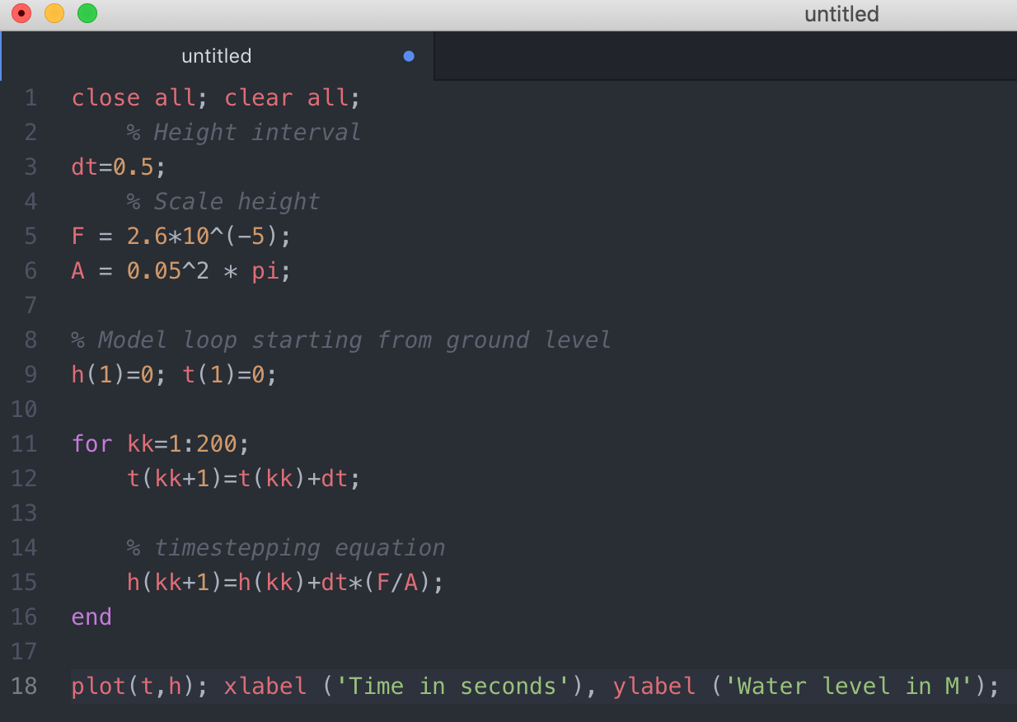

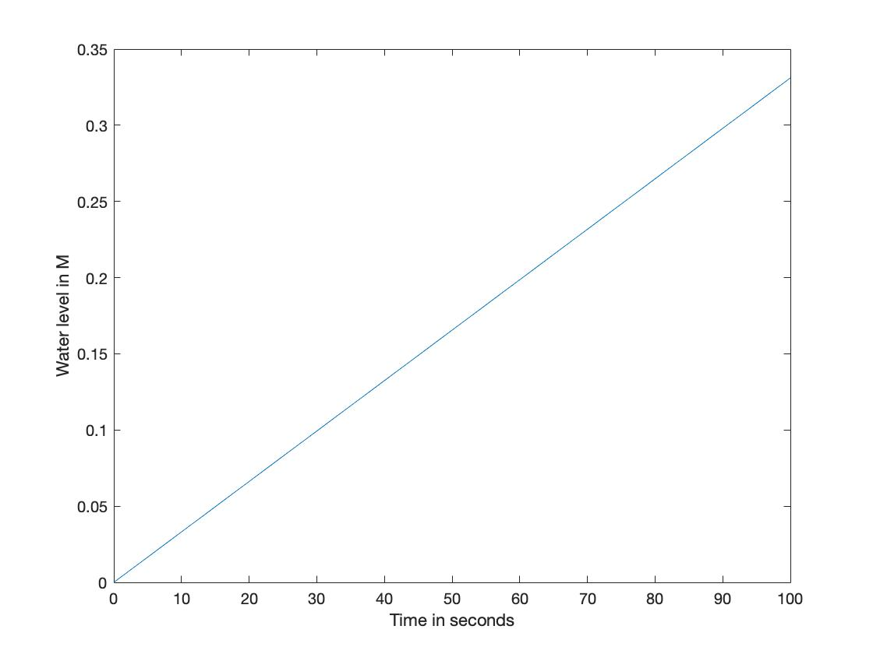

The numerical solution is quite sensitive to big increments in time. The resolution of the result increases with smaller increments. This is why I have set the increment to 0.5 seconds, but it could be set to even finer increments if desired.

* 1. The area of the semi spherical bucket can be calculated with which takes the ever-changing radius into consideration. Thus, A in the formula from **1.4** can be replaced with this and then recalculated.

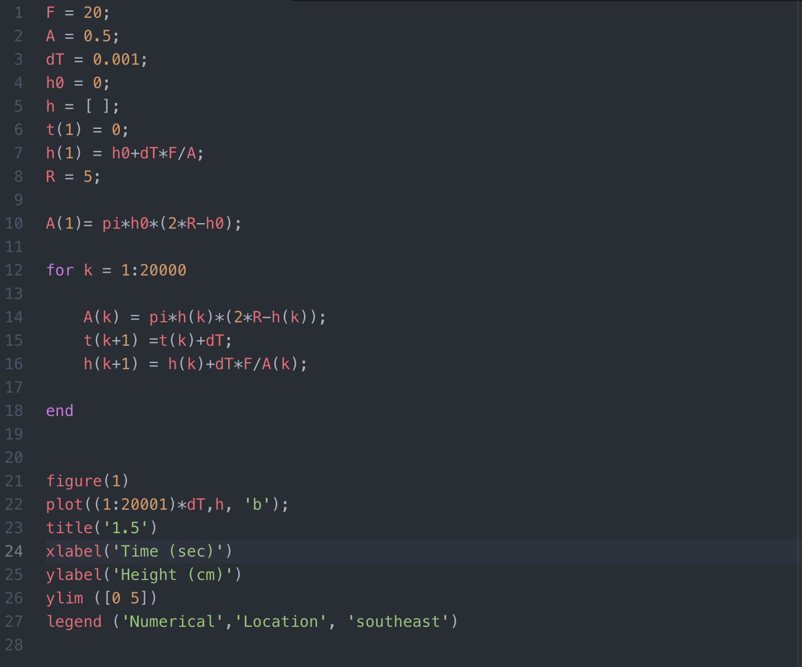

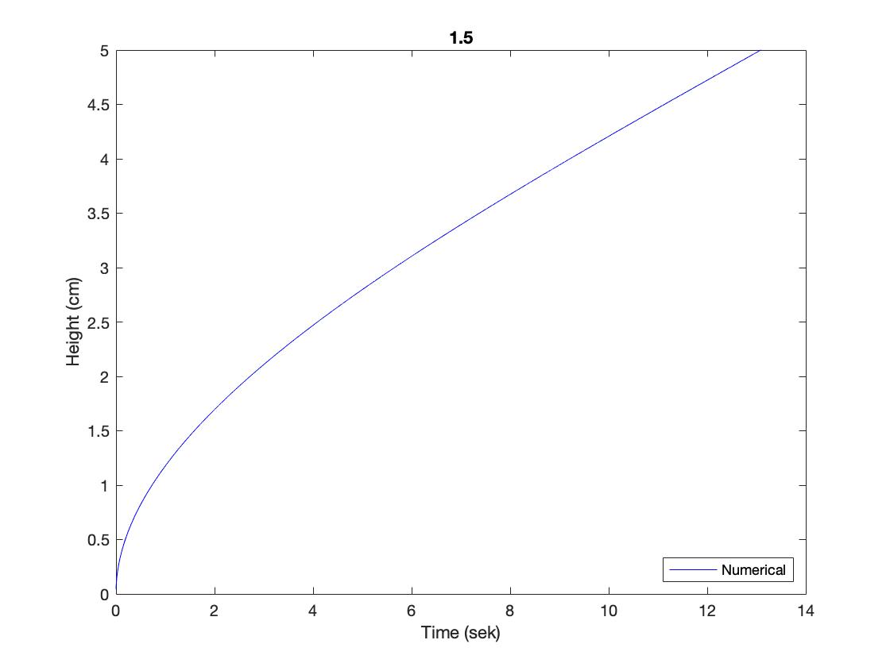

**2.1**

**2.2**

**2.3**

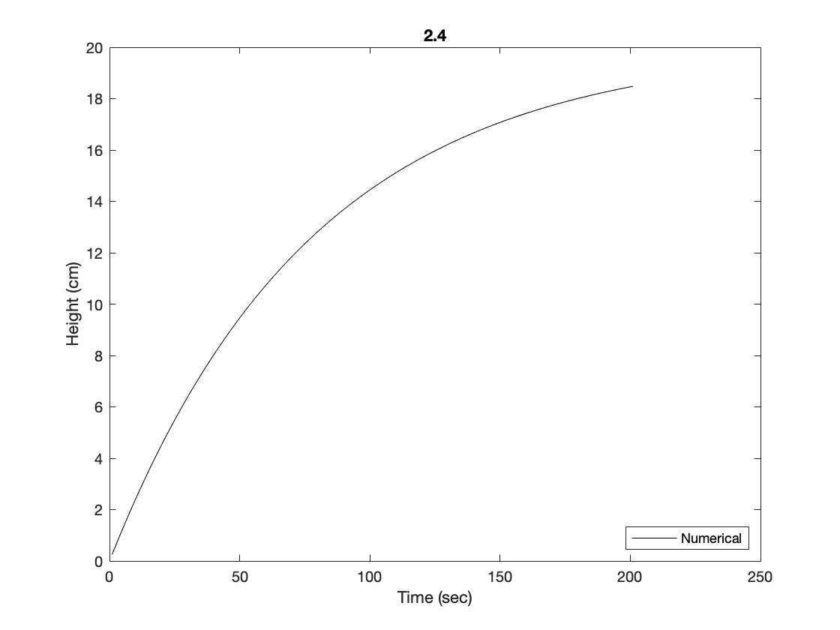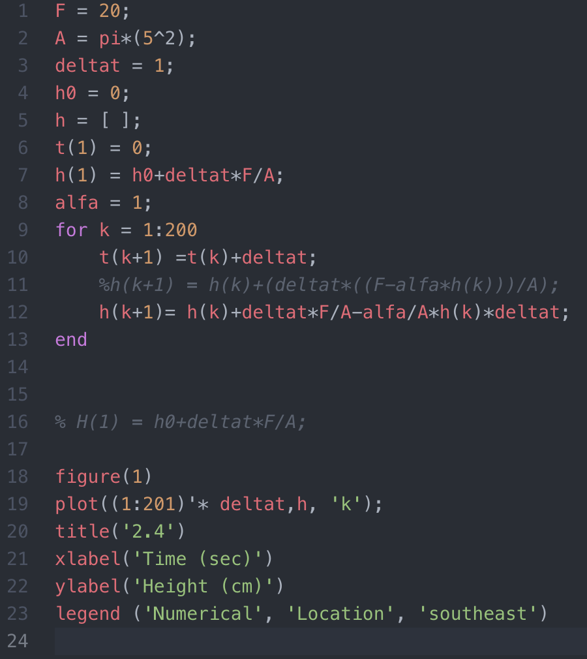**2.4**

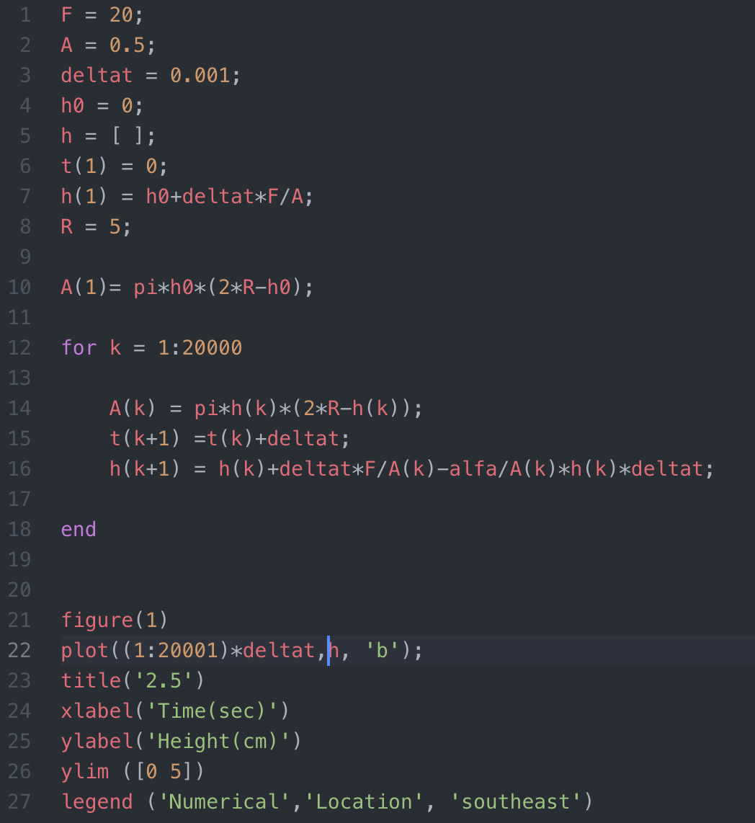**2.5** 